The Obsessed Automobilist
By David Berthon

The Rolls-Royce Phantom II introduced in September 1929 was a big step up from Henry Royce’s earlier designs. Unlike the Phantom I, which had inherited its underpinning from the legendary Silver Ghost, the Phantom II employed an entirely new chassis design.

Built on two wheelbase lengths the most sought-after collector Phantom II today is the high-performance Continental introduced in 1930 on the shorter 3,700mm wheelbase frame. Just 156 were produced in right hand drive with just two imported into Australia when new. Of the seven Rolls-Royce PII Continentals now known here one late import has a fascinating history and carries rather handsome coachwork by Barker and Co.

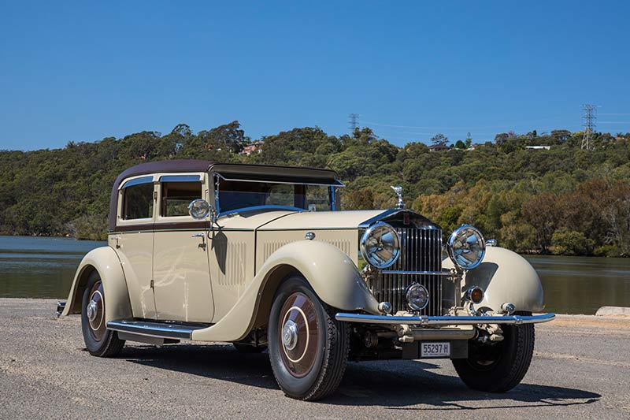

Imported in 2015 this low-slung 1931 close-coupled sports saloon was supplied new in the U.K. to the celebrated horse racing identity, the Hon. Dorothy Paget. Chassis 48GX, just one of several Rolls-Royces that would be delivered to the overtly eccentric and immensely wealthy racehorse owner and breeder.

Dorothy Paget had financed the team of Blower Bentleys created by Sir Henry ‘Tim’ Birkin. Paget’s love of horsepower of a different kind was fostered after she was introduced to Birkin at the 1929 500-mile Brooklands race.

In early 1930 she would buy Birkin’s three 4 1/2-litre Blower Bentleys as well as a mystery ‘blown’ single seater which was still under development. Her venture into car racing would quickly prove profitable with Birkin breaking the track record at Brooklands in the April.

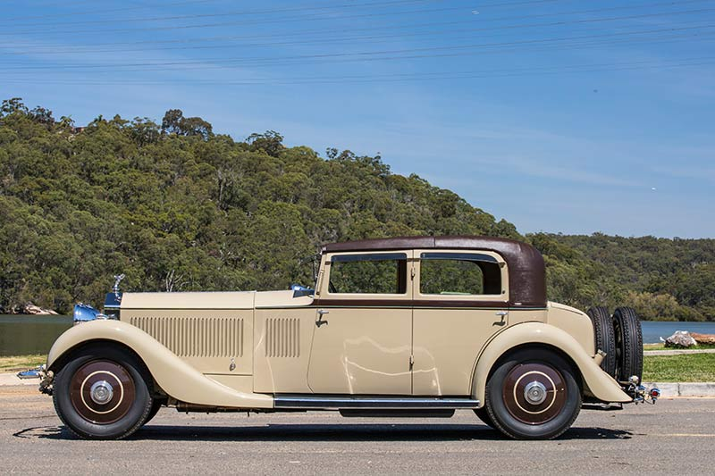

Under his guidance Dorothy Paget would soon become an enthusiastic driver in her own right, Birkin even suggesting she was one of the finest women drivers of fast cars he’d come across. However, one suspects he was playing to her ego having run out of his own money and given his desperate need for sponsorship support with W.O. Bentley refusing to fund the blower project. Dorothy was in fact his passenger when Birkin lapped Phoenix Park in Ireland at an average 80 mph telling the Daily Express that she had been thrilled adding, “I must do a lot more of it.”

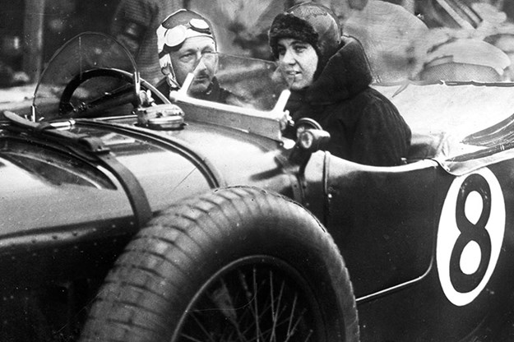

Sir Henry ‘Tim’ Birkin with Dorothy Paget in one of the Blower Bentleys.

However, her interest in speed soon waned given the poor performances of the 41/2 ‘blowers’ and by October it was announced that she was retiring from motor racing, her one-year foray costing over 40,000 pounds but well below what she was lavishing on horse racing. She did however retain ownership of the single-seater track racer which was the only ‘blower’ to win at Brooklands, Birkin setting fastest lap in the Kent Long Handicap at 126.73 mph.

Since the PII Continental’s arrival in Australia no expense has been spared in bringing it up to the finest standard. On top of considerable mechanical work, it has undergone a full repaint and a new hand-crafted leather roof, the work rewarded with a win in the Pre-War Closed Class in the Australian Concours d’Elegance held at the 2016 MotorClassica in Melbourne.

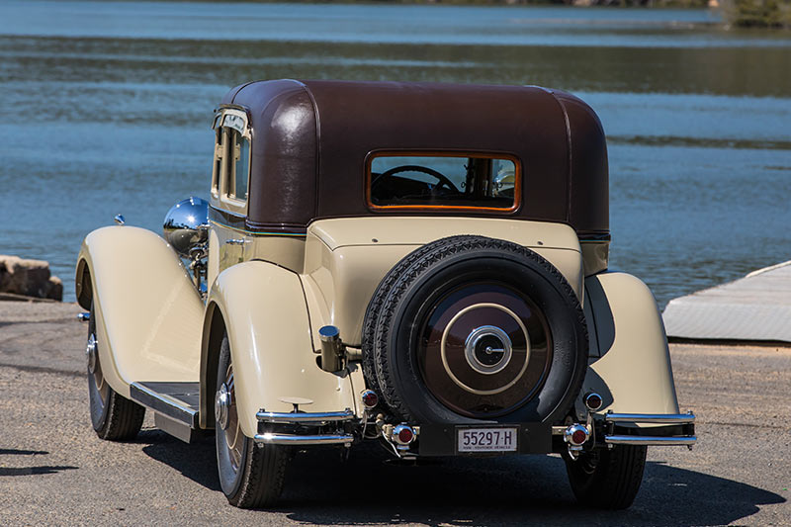

Driving this car it quickly becomes obvious that it has done little work – one tell tale of early Rolls-Royce’s and whether they’ve done high mileage is the wear on the accelerator pedal and this car’s shows little use. Dorothy Paget had bought the Phantom II Continental on a whim after her early edition of 1929 Phantom II broke down on its way to Ascot. Dorothy got out hailed the local butcher’s van and offered him an excessive sum to buy it and complete the journey.

When she got home, she immediately ordered the Phantom II Continental so that one Rolls-Royce could follow the other in case such a breakdown should occur again – it never did and when two Rolls-Royce’s approached a racecourse everybody new Dorothy Paget was arriving. But this behaviour had become very much the norm for the weird and wacky world of Dorothy Paget – born enormously rich, difficult and very eccentric she made headlines wherever she went becoming a household name for all the wrong reasons.

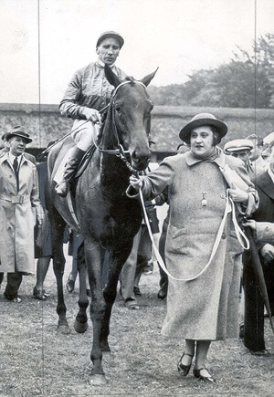

The daughter of an English aristocrat and an American heiress Dorothy grew up spoiled and unloved as a child, expelled from at least six schools, growing to become an unhappy woman who would eventually weigh 20-stone, paying little attention to her appearance. Domineering and abominably rude she knew that despite her immense wealth, she would never attract a man.

Restless and chain-smoking 100 Sobrani’s a day she became a compulsive gambler, betting millions daily and invariably backing her own horses having built a substantial racing stable. In all her horses would win 1,532 races including the coveted English Derby in 1943. Yet despite considerable winnings her sojourn on the turf was said to have cost 90 million pounds without considering her substantial gambling losses.

Domestic life at her mansion at Hermits Wood in Buckinghamshire was weird at best – she would have breakfast at 8.30 in the evening and by midnight she would be ready to telephone her trainers to discuss the next day’s racing program. Dinner would be at 7.00 in the morning followed by a long sleep. She only hired female staff and despised men so much that she claimed they made her physically sick.

Gaining the title of the Queen of the Turf, the Honorable Dorothy Wyndham Paget would die relatively young, just short of her 55th birthday in 1960 leaving a fortune estimated today at 100 million pounds. By comparison, her superb Phantom II Continental is today in very fine fettle in its 96th.year.

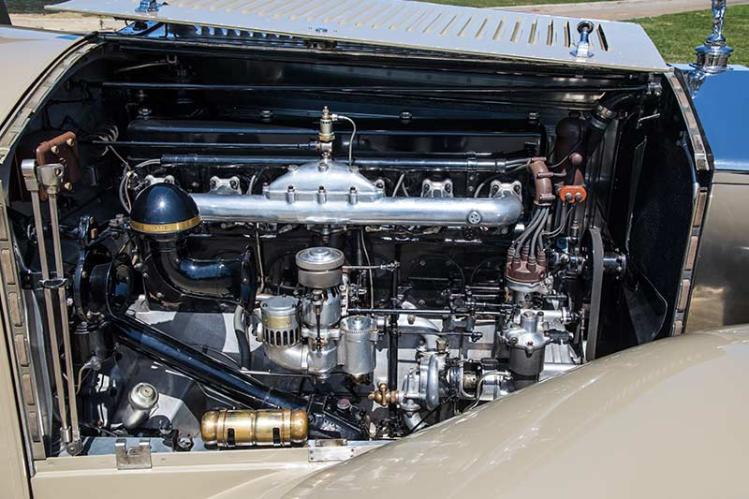

Henry Royce’s last personal design, the PII Continental was intended more as an owner driver’s car featuring a revised rear suspension with stiffer springs, lower rake steering column and a taller rear axle ratio. Royce followed much of the Phantom I’s cylinder dimension and basic layout for the 7,668cc OHV engine with two blocks of three cylinders and an aluminium cylinder head common to both blocks. However, the combustion chamber and cylinder head were redesigned as a crossflow design with inlet and exhaust manifolds now on opposite sides.

Unlike the earlier 40/50HP models the four-speed gearbox also bolted directly to the engine providing a lower more rigid driveline with an enclosed clutch driving through an open driveshaft to a hypoid bevel final drive. The new low-slung driveline and chassis frame sitting on semi-elliptic springs front and rear enabled coachbuilders the opportunity to build a lower sleeker body design as distinct from the more upright designs of the past.

Stiffer, five-leaf semi-elliptic rear springs and a 150mm shorter wheelbase mean ride quality on the Continental is less compliant and more-sporty to the standard PII chassis. But more importantly, the hydraulic shock absorbers adjust their damping action according to the speed but can be readily controlled manually by a small lever on the steering column. Royce continued the powerful servo-assisted brakes from the Phantom I but also added the Bijur centralized lubrication system via a pedal mounted on the dashboard.

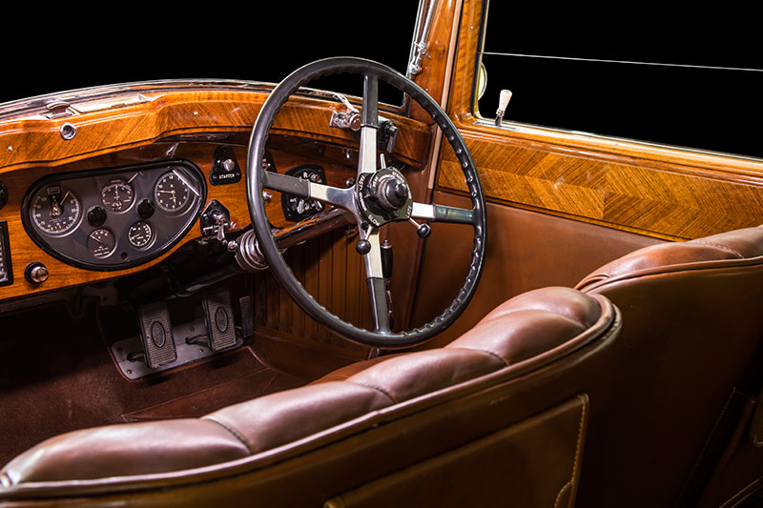

Most noticeable on start-up is the smoothness of the engine – very polished and flexible and whilst Henry Royce saw this car as a competitor to the 8-litre Bentley it is far quieter and more refined in operation. Perhaps a trademark of Henry Royce’s chassis designs is their docile nature despite an abundance of power. Flexibility is a highlight and the 7,668cc overhead valve six-cylinder will happily throttle down in top gear to around 10km/hour and around 200 revs on a retarded spark.

However, punch the throttle hard and it quickly shows its potential only limited by the slowness of the non-synchromesh gearshift – the early PII’s did not feature synchromesh, and it was slowly implemented across later years, on third and fourth gear in 1932 and on second gear in 1935. As such, I found this early model PII Continental a little slower through the gears and requiring more concentration compared to later models I’d previously driven.

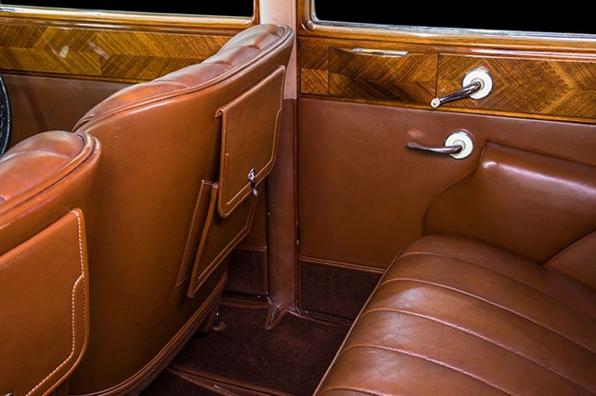

The car’s sweet spot on the open road is 90 km/hour, quiet, smooth and still with a comfortable ride despite its sporty pretentions. Noticeable is the lack of body roll compared to the higher riding Phantom I. Most PII’s are heavy in the steering department, given an all-up weight of around 2600kgs, and this car is no exception especially at parking speeds. Although, at the time of this test there was some conjecture that the one-shot lubrication system may not have been doing its job properly with the king pins. Many owners today counter the heavy steering by adding power steering – a welcome addition for manoevrabilty modern traffic conditions.

Braking on the other hand via Henry Royce’s excellent servo-assisted mechanical setup is as good as any post-war hydraulic system, powerful with great feedback through the pedal. When one considers that this car arrived at the height of the Great Depression its considerable style and presence, particularly in the hands of Dorothy Paget, must have really made a statement.

When one considers that this car arrived at the height of the Great Depression its considerable style and presence in the hands of Dorothy Pagent must have really made a statement.

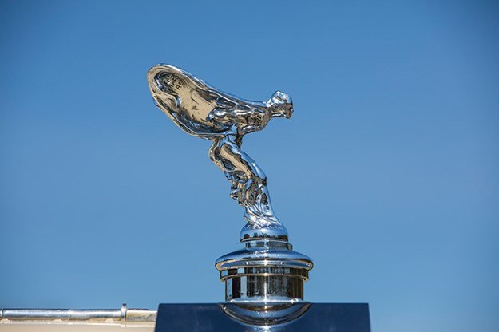

1931 Rolls–Royce Phantom II Continental 48GX
Price when new: Chassis £1,750.00,
Continental Touring Saloon £2,425.00
Engine: Six-Cylinder OHV 7,668cc dual ignition
Gearbox: Four speeds with final drive 3.4 to 1
Chassis: Channel section with centralised lubrication
Steering: Worm and Nut
Springs: Semi-elliptic with adjustable hydraulic dampers
Brakes: Servo-assisted drums
Wheels and Tyres: 700 x 19-inch
0 to 100 km/h: 20 seconds
Top Speed: 144 km/hour

